# Control And Display Unit(CDU)

Development Proposal

#### Introduction:

The Control and Display Unit (CDU) serves as the main control unit for tuning and managing three navigation systems: VHF Nav Radio (VOR, Localizer, and Glide Slope), TACAN, and ADF. The CDU features an alphanumeric keypad and software-defined keys for selecting and interacting with these systems. The CDU sends tuning data in the NMEA 0183 format and works in sync with Remote Control Panels (RCP), ensuring that active, standby, and stored frequencies are aligned across the systems.

#### Features:

* Sync with each RCU
* Setting Standby Freq. Using keyboard
* Alpha Numeric Keypad along with Software defined keys
* Display the Input and Output
* Updating the Internal Memory

#### Interface Specifications:

UART_1: On one of the serial port, CDU has to interact with three systems through their RCP. The interface need to be clearly defined so that the data can be interchanged without any ambiguity. The details are given in the ICD (Interface Control Document). The main emphasis here is to formulate a method that can be used at the 1553 controller to direct the CDU in/out-bound messages to appropriate RT.

UART_TFT: On another serial port, Nextion LCD is connected. The details of the Nextion Display interface will be covered through design document.

UART_2 - 4: TBD

Can Interface: TBD

#### System Block Design

The functional block design of system with CDU and RCP is as follows

RCP-TACAN

RCP-NAV

CDU

1553

RCP-ADF

#### CDU Function Block Design:

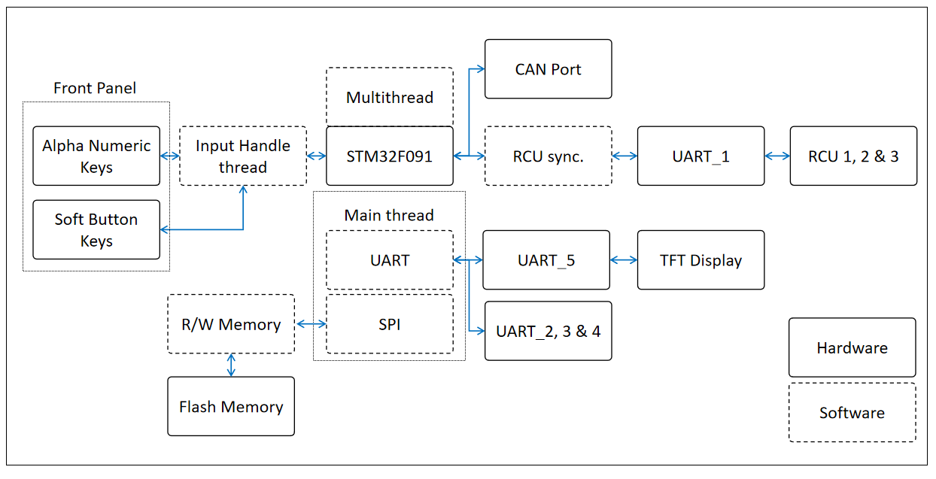

#### User Interface

The User Screen will be decided during the Design phase. Below are some example screens.

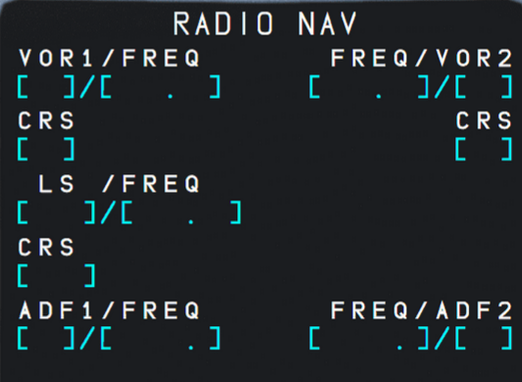 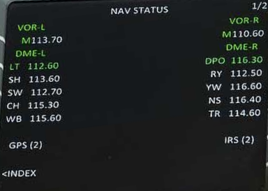

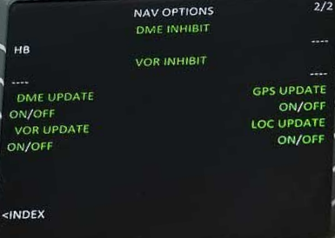 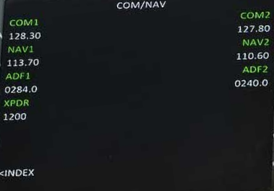

Soft Buttons: TBD

56 Keys Keypad: TBD

#### Development Milestones

The Development steps can be divided into following

1. User Interface Definition
   1. LCD Pages Definition
   2. Button Functions
2. Generating simulated values through PC to test communication with RCP
3. Writing the RCP SW for CDU connectivity
   1. Implementing the ICD for CDU-RCP Connectivity
   2. RCP Internal Variable and Display update on change from CDU
4. CDU Peripheral Driver
   1. Nextion LCD
   2. 56 Keys Keypad
   3. SPI Flash
   4. CAN Bus
5. Display Pages implementation for received and internal equipment info
6. User interface (Soft Keys and Key pad) implementation
7. Testing